Flowchard piramid 1

Start

Input user

i=Input user

i + 1



print i

Flowchard piramid 2

Start

Input user

i=Input user

i - 1



print i

Flowchard (If, Else)

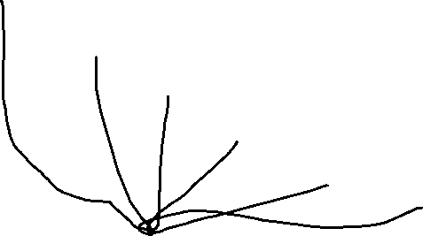

Predikat -B

Predikat +B

Predikat A

Peredikat -A

>=80uf

Predikat A

>=90

Predikat B

Predikat C

Predikat D

>=50

>=40

>=75

>=70

>=60